**Table of Contents *(hold your Control Key to click)***

1. **Access the Online Procard Training** **2**

1. **Access the Procard Transaction Management System (PTMS) 3**
2. **How to upload receipts in PTMS** **4**
3. **How to reallocate a charge 8**

1. **How to mark a transaction as Disputed 10**
2. **How to approve a transaction as an approver** **11**
3. **How to reject a transaction back to cardholder’s queue** **121**
4. **How to mark a transaction in Violation** **13**
5. **PTMS - FAQs** **14**

**To access the Online Procard Training**



**Step 1**: Logon to **academica.wayne.edu** with your Access ID and password**Step 2:** Click on **Employee Resources** located under the *Resources* section**Step 3**: Click on the **Other Resources** link**Step 4**: Click on the **Accelerate Employee Development Tools** link

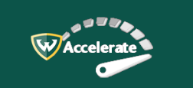  
**Step 5:** Click in the Search field at the top, and type “Procard”

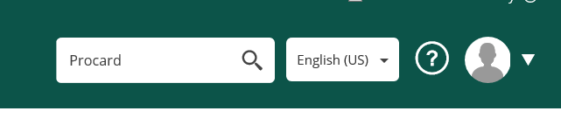

**Step 6:** Click **Procard** link for an Overview

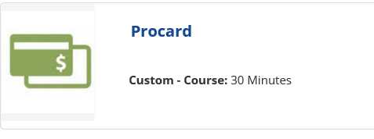  
**Step 7:** Click the **Launch** link to execute the training course

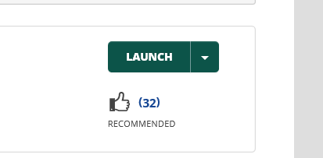

**To access the Procard Transaction Management System (PTMS)**



**Step 1:** Logon to **academica.wayne.edu** with your Access ID and password**Step 2:** Click on **Employee Resources** located under the *Resources* section**Step 3:** Click on the **Document Management** link**Step 4:** Click on the **ProCard Transaction Management System** link.

**How to upload a receipt in PTMS**

**Step 1:** Click on the drop down menu under “Please select an option” and click on Process monthly Procard transactions for the month of _______

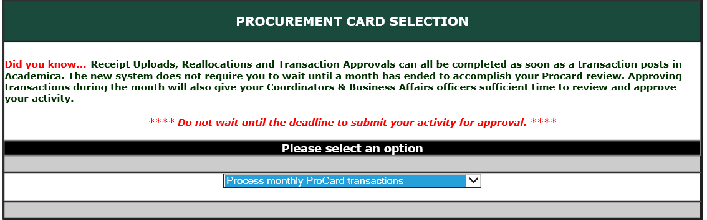

**Step 2:** Double click on the Last 4 Digit Hyperlink for the appropriate card

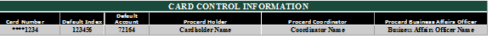

**Step 3:** Double click on the Yellow Action Folder



**Step 4:** Click on “Browse” to select your PDF receipt (*Hint: scan all your receipts onto your desktop in a single file folder, for easy Windows navigation to them)

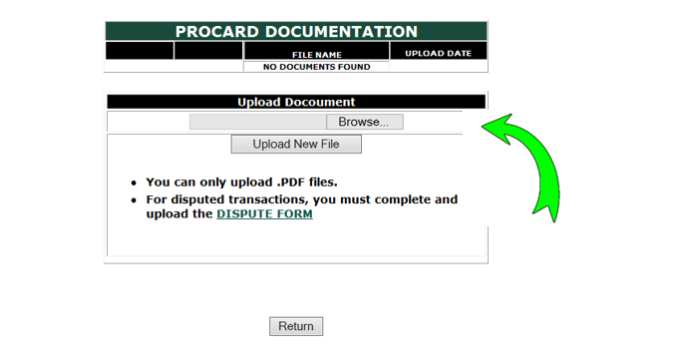

**Step 5:**

**a.** Once you have selected your PDF document and clicked on “Open” – your document will populate into the field.

**b.** **Click o**n “Upload New File” to upload your receipt document

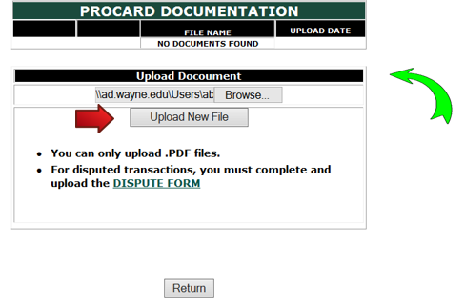

**Step 6**:

1. When you have uploaded your receipt, a notification will appear to confirm you have successfully uploaded your document.
2. You may click on “View” at the top to review your receipt, or “Delete” if you would like to remove receipt (i.e. wrong document).
3. Click on “Return” to return to your transaction information.

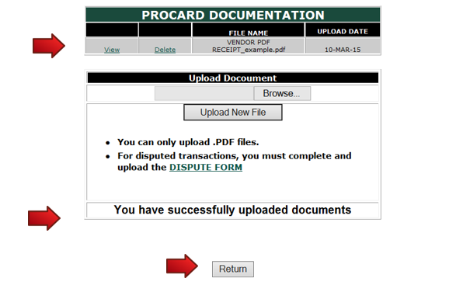

**Step 7:** When you have uploaded your receipt, a green check mark will appear. **NOTE:** You **MUST** click on the green check mark to approve your transaction. *Both steps (uploading receipt and approve transaction)* ***MUST*** *be completed by the 4th business day of the month for the prior month’s transactions. Failure to complete both steps by the deadline (upload receipt and approving transaction) may result in card suspension.*

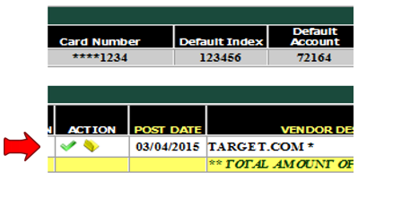

**Step 8:**

1. Once you have clicked on the green check mark this window will appear. The drop down menu has choices – “Approve Transaction”, “Approve as Disputed”, and “Approve as Violation”
2. Select **“Approve Transaction”**
3. You may add comments below to add further details of the transaction.
4. Click on **“Update”** to return to the transaction information.

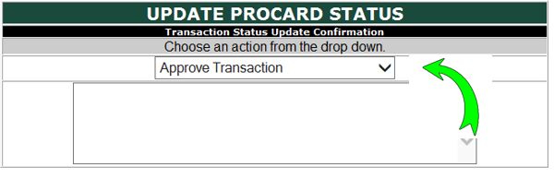

**How to reallocate a charge *(note: applies to cardholder and coordinator only)***

**Step 1:** Click on the Reall/Split Icon:

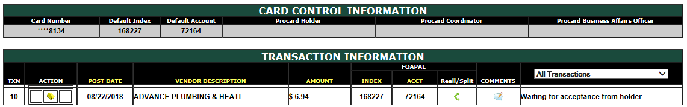

**Step 2:** Enter the index in the Index field in which you would like to transfer funds. (**Note:** the total amount of the transaction will already appear in the Amount field)

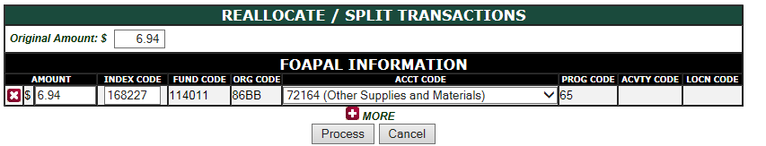

**Step 3:** After you have entered index, hit “Tab” on your keyboard, and the fund, org, and program code will automatically default.

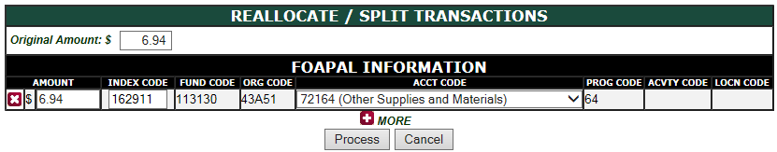

**Step 4:** Your Account Code section should now be highlighted. Click on the drop menu to select your account code (if necessary)

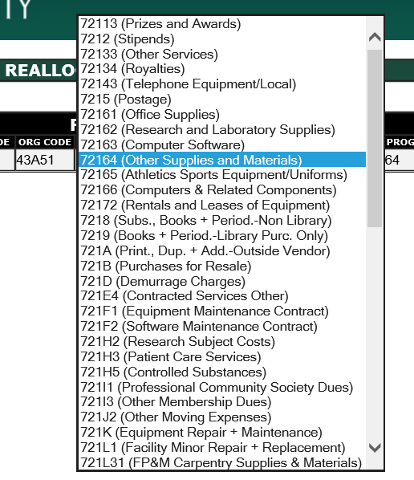

**Step 5.** Click on **“Process”.** This step completes a reallocation for one transaction, and you will automatically return to the transaction information. An **“R”** will appear in red, which confirms that the transaction was successfully reallocated.



**Step 6.** If you would like to split the amount between two accounts, you would click on https://cardinal.wayne.edu/procard/images/plus.jpgMORE

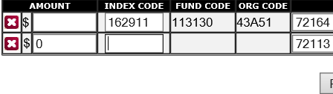

Click on **“Process”.** This step completes a split reallocation for one transaction, and you will automatically return to the transaction information. An **“S”** will appear in red, which confirms that the transaction was successfully split.

**How to mark a transaction as Disputed**

**Step 1:** Download the **Dispute Form** which is located on our website [www.procard.wayne.edu](http://www.procard.wayne.edu) under the “Procard Forms” tab

**Step 2:** Fill out the form, and submit a copy via an email pdf attachment to the Procard Office at [procard@wayne.edu](mailto:procard@wayne.edu). The Procard Office will send an email confirmation that the dispute has been filed with our Procard provider: Bank of America.

**Step 3:** Upload the completed dispute form for that transaction. Follow steps 1 through 8 in “**How to upload receipts in PTMS**”. The drop down menu has choices – “Approve Transaction”, “Approve as Disputed”, and “Approve as Violation”

**Step 4:** Select “**Approve as Disputed**”

**Step 5:** Add comments below regarding the dispute charge. (**note:** stating that you have notified the Procard Office is sufficient)

**Step 5.** Click on **“Update”** to return to the transaction information

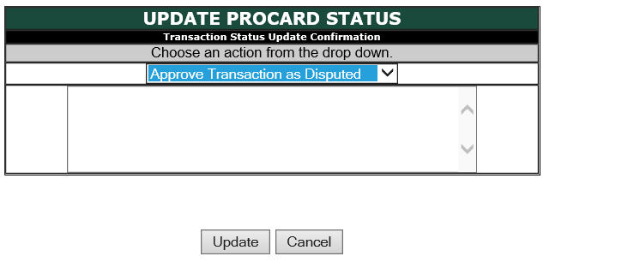

**How to approve a transaction as an approver (i.e. coordinator or BAO)**

**Step 1:** Once the cardholder has completed the steps 1 through 8 in “**How to upload receipts in PTMS**” the transaction will now appear in your queue in **boldface.** You will also receive an email notifying you that you have transactions to approve.



**Step 2:** Click on the green check mark 

**Step 3:** Once you have clicked on the green check mark this window will appear. The drop down menu has choices – “Approve Transaction”, “Approve as Disputed”, and “Approve as Violation”

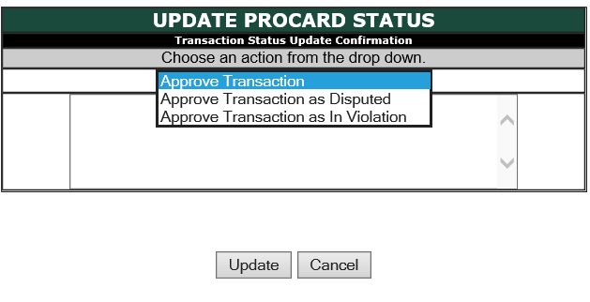

**Step 4:** Select **“Approve Transaction”**

**How to reject a transaction and return it to the cardholder’s queue (*Note: applies to coordinators and BAOs only*)**

**Step 1:** Once the cardholder has completed the steps 1 through 8 in “**How to upload receipts in PTMS**” the transaction will now appear in your queue in **boldface.** You will also receive an email notifying you that you have transactions to approve.



**Step 2**: Click on the Red “X” to reject the transaction.

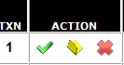

**Step 3:** Add comments outlining the reason for rejection before proceeding.

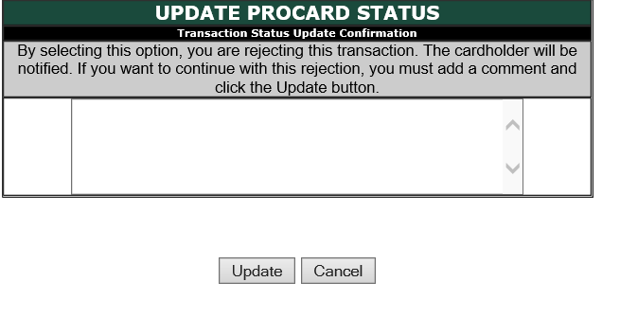

**Step 4:** Click **“Update”.** Once transaction is rejected it is considered “Pending” until the cardholder reapproves the transaction.

**NOTE:** Although a cardholder will be notified via email, it is important that cardholders periodically check for any rejections and reapprove timely.

**How to mark a transaction in Violation**

**Step 1:** Once the cardholder has completed the steps 1 through 8 in “**How to upload receipts in PTMS**” the transaction will now appear in your queue in **boldface.** You will also receive an email notifying you that you have transactions to approve.



**Step 2:** Click on the green check mark  this window will appear. The drop down menu has choices – “Approve Transaction”, “Approve as Disputed”, and “Approve as Violation”

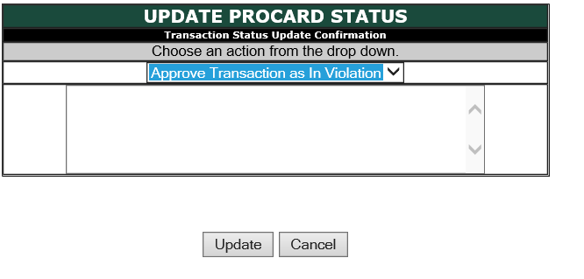

**Step 3:** Select **“Approve as Violation”**

**Step 4:** Add comments below to add reason of violation

**Step 5.** Click on **“Update”** to return to the transaction information

**PTMS - FAQs**

Q: What if I lose my receipt or the vendor did not submit a receipt?

A: Notify the coordinator and Business Affairs Officer (BAO) in writing (via email), and document vendor, price, and brief description and purposes, and convert the email into a PDF and upload as a receipt document. In most cases, this will satisfy the receipt requirement.

Q. What if my coordinator rejects my transaction, does this mean the vendor did not receive payment?

A: The PTMS is a separate University system, independent of Bank of America. When approving/rejecting transactions, this does not mean the vendor was not paid. By the time transactions are available in PTMS, the vendor has typically already been paid.

Q. I often use Safari browser, and when I access my PTMS I receive an error message, why?

A. PTMS is most compatible with Internet Explorer. Other applications such as Safari, Firefox, or Chrome may cause errors, depending on the version used.

Q. What if there is a transaction that posted to my account and I don’t know where it came from?

A. Fill out the [**Dispute Form**](https://procard.wayne.edu/forms/wsu-dispute-form-2015.pdf) , and send a copy to the ProCard Office. (*Follow Steps in the Job Aid **How to mark a transaction as Disputed**)

Q. I provided the University’s Tax ID number, but the vendor would like the Tax Exempt Certificate, how can I get it?

A. Notify the ProCard Office, and one will be provided for you. We will need the full Vendor name and address, in accordance with the State of Michigan form.

Q. I am on leave, and the ProCard deadline is approaching. I don’t want to risk my ProCard being shut off. Can I get an exception?

A. Somewhat. You must adhere to the following steps:

1. Alert your designated coordinator, and the ProCard Office immediately via email.
2. Send receipts to coordinator and ProCard Office upon your return

The Procard Office will upload a copy of the email to demonstrate knowledge that the transaction is not being approved. When the receipts are sent to the Procard Office, they will also be uploaded to the transaction. The transaction will indefinitely remain “pending”, since no transaction can be approved after the 15 calendar day after any given month.