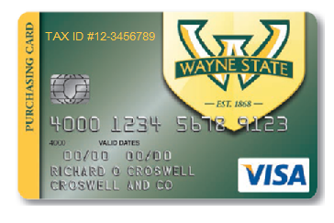
To access the Procard Training
From Academica
Step 1: Logon to academica.wayne.edu with your Access ID and password
Step 2: Click on Student Resources located under the WSU Resources section
Step 3: Click on the Canvas link
Step 4: Paste the following link into your browser:
https://canvas.wayne.edu/courses/93385
You may also select from the shortcut by clicking on the Canvas Icon at the top next to the Email Icon.
Here is the URL link to enroll into Training https://canvas.wayne.edu/enroll/3ERRW7

To access the Procard Transaction Management System (PTMS)
From Academica
Step 1: Logon to academica.wayne.edu with your Access ID and password
Step 2: Click on Employee Resources located under the WSU Resources section
Step 3: Click on the Document Management link
Step 4: Click on the ProCard Transaction Management System link.

